**Frank Hertz Experiment**

**By Michael Lane**

**Background**

During the Era of World War I, physics had just begun to tackle the problem of quantization as observed in the Millikan oil drop, Mosley X-Ray Diffraction Experiment, and other experiments that probed the properties of the atom, atomic spectra and the Einstein would later define as the photoelectric eject. The Franck-Hertz experiment, rest conducted in 1914, is a historic experiment that showed quantized internal energy excitation in atoms. In fact, both Frank and Hertz would earn then Nobel peace prize for their work later. During his acceptance of this award, Dr. Frank remarked how, “It might interest you to know that when we made the experiments that we did not know Bohr's theory. But we did not know whether that would be so, and we did not know whether at all an emission of an atom is of such a type that one line alone can be emitted and all the energy can be used for that purpose. The experiment gave it to us, and we were surprised about it. But we were not surprised after we read Bohr's paper later, after our publication" [1]. Though it would was an accident, conurbation for Bohr’s theory of the hydrogen atom, which would later allow developing a full quantum understanding of the atom using Planck’s constant [1].

**Theory of the Photodiode Tube:**

In the Franck-Hertz experiment, electrons are accelerated by an electric held through a monatomic vapor, in this case Neon, Mercury, or Helium. The electrons traveling through the vapor collide with the atoms. These collisions are completely elastic unless the electron has more energy than the rest excited state of the atom. In such an elastic collision, the energy transferred to the atom by the electron is found from basic no relativistic kinetics to be:



Here K = Kinematic Energy while m and M = the masses of the two colliding atoms.

When the energy of the incident electrons is greater than the energy necessary to excite the atom, inelastic collisions can take the atom to one of its low-lying excited states. The electron loses this energy. After the collision, subsequent acceleration of the electron may bring it once again into an energy regime where it can in elastically collide with the atoms in the vapor. To measure the energy of electrons after they have traveled some distance in the atomic vapor, an electric field that decelerates the electrons is introduced between grid and an anode [Fig 1]. The potential is chosen so that electrons with relatively high kinetic energies will pass between the grid and anode, resulting in a measureable current retardation between the anode and the grid. Less energetic electrons will pass through the grid and then return to it instead of reaching the anode. These electrons

do not contribute to Iag . Researcher have pointed out that using this grid technique for measuring the current is intrusive and eﬀects the experimental results [2].

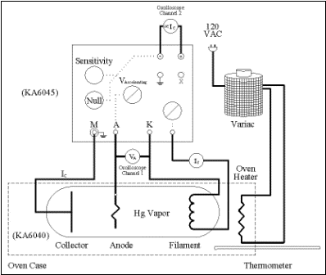

FIG. 1: Experimental setup and wiring. In the commercially available Franck-Hertz experiment apparatus, which is a glass tube with a small quantity of liquid mercury is heated so that some of the mercury goes into the gas phase. Electrons are liberated within this tube by a heated ﬁlament (F) and accelerated through the gas by an applied voltage (Vacc ) between the cathode (H) and the grid (G). A retarding electric ﬁeld produced by another connection is applied between the grid and the anode (A). The resulting current ﬂow between the grid and anode (Iag ) is measured by a precision picometer.

The physical picture presented is very idealistic. For example, it ignores the elastic collisions, electron-atom interactions in the region of space between the grid and anode, and velocity distributions of atoms and electrons. Over the years experiment has been refined taking into account modern kinetic theory of gases [3–5]. One thing that has not changed however, is the concept Hertz introduced to Franck of the wavelength of a light that the electron release is directly proportional to the energy loss as the electron/ion’s discharges and decelerates. With V = the accelerating voltage, h = Planck’s constant, lamda. This is formula is:

(2)

I will use this formula for the Hydrogen to find Plank’s constant. For the Neon and Mercury, In order to conduct the experiment, we used a commercially available Franck- Hertz apparatus from the Klinger In this apparatus, both vapors vapor was heated to temperatures between 130 and 180◦ C in a glass tube. Electrons liberated from a heated ﬁlament by means of an applied voltage, Vf, were accelerated through the both a mercury vapor and a neon vapor by an applied electric ﬁeld [Fig 1] Mercury was used for this experiment because its vapor is monatomic. Monatomic vapors are preferred over molecular gases such as hydrogen for this experiment. Molecular gases have closely-spaced ro-vibrational states that electively wash out the quantized states in the excitation spectrum. Furthermore, mercury’s vapor density is variable with temperature, an easily controlled experimental variable.

Fig. 2. Plot of Current vs. Voltag for Mercury.

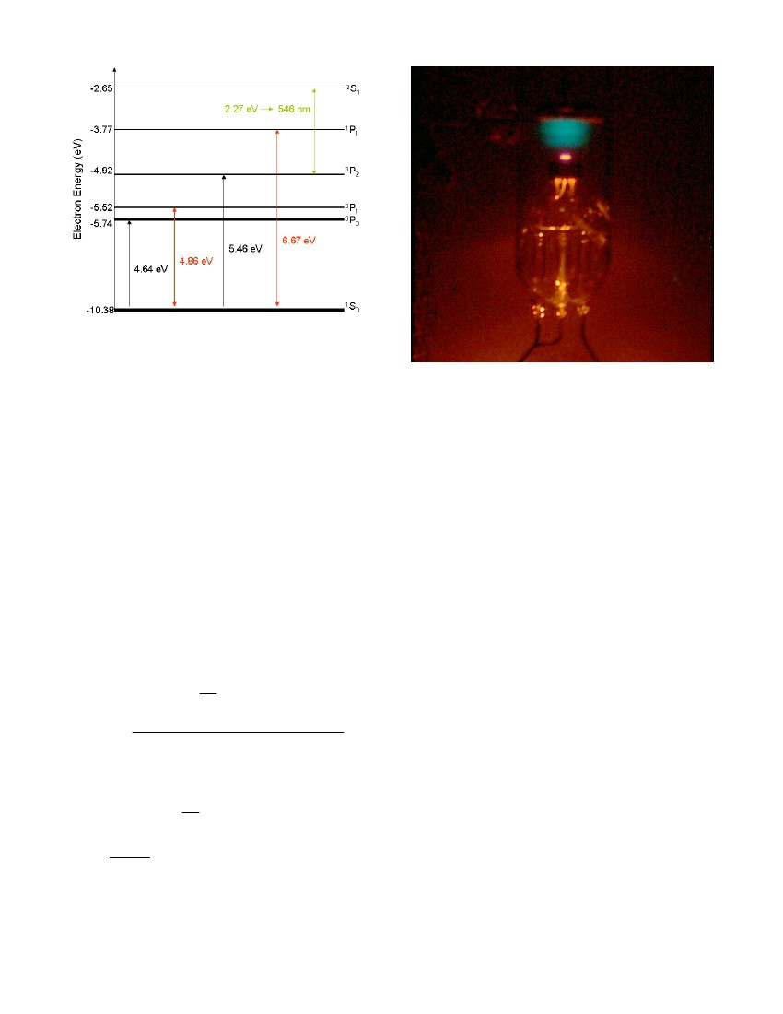

Fig. 3a) Spectrum of the Mercury atom.

The lowest lying states of mercury that can be accessed by inelastic collisions are the transitions from the 1 S0, speed of light, e is the charge of an electron and V0 is th excitation potential for the 1 S0 →3 P1 transition. It is the acceleration electrons up to and discharges between these states that causes the voltage and amplitude to form like in Figure 1. Because some states are quashed, Frank and Hertz found that the maximum of the voltages could be plotted vs. an arbitrary number n. Then, by taking the slope of the plot they get a change in the energy between states. It turns out that in the setup above, that change in energy is the ground state of the atom from its ionization state as zero. [see Figure 3].

**Theory of the Spectrogram:**

Beyond the simple measurement of the Photodiode’s electrical potential change, Frank and Hertz observed that they could actually take the lamp and measure its spectrum using a spectrograph diffraction grating device. We measure the wavelength by taking the differences in the angles of left and right the line we observe is from center.

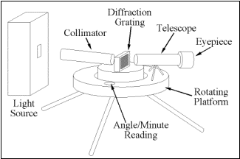

Figure 3b) Picture of the Spectograph

**Results for Neon and Mercury:**

For the conducted experiment, we measured the periodicity of the electron energy at the grid as follows for neon and mercury (Fig. 2 and Fig 4) .

Fig. 4 a).Very top Plot of Current vs. Voltage for Neon. b) Top: The linear fit for Mecury of to measure the first excited state/ground state transition c) Bottom: The linear fit for Neon of to measure the first excited state/ground state transition

Using pen and paper, anode current Iag was recorded while Vacc was increased from 0.0 to 45.0V in increments of 0.05V. Each ﬁle was the analyzed using Microsoft Excel 2003 where we fitted both the Neon and Mercury data to lines. Electrons that reached the anode were registered as negative current. Because electrons were decelerated between the grid and anode, this current is a measure of the electron. The excitation potential was measured to be 4.92 ± 0.02 eV. This value agrees with the expected value of 4.86 eV of the ground state 1 S0 →3 P1 transition [7]. For Neon, the measure value was 16.1 ± .9. I had some difficulty due to the fact that the first peaks mode did not produced a visable peak. Thus I only got to data points and this limitation was the primary factor behind the high error value.

Overall though it still shows the quantization of atoms to the fact that the Maximum accelerating voltages are actually incrementally increasing by the same factor or packet of energy, which are called quanta,

**Results for Helium**

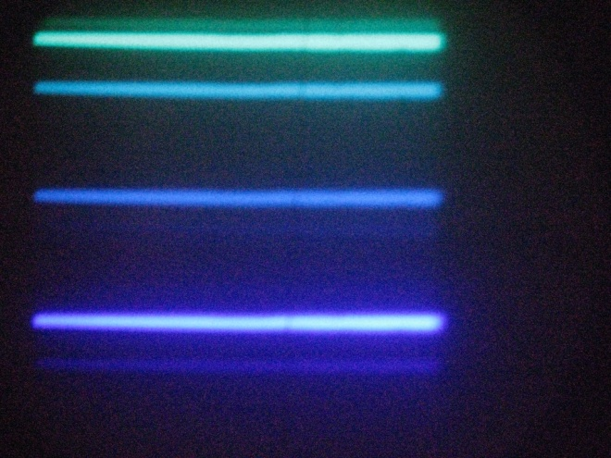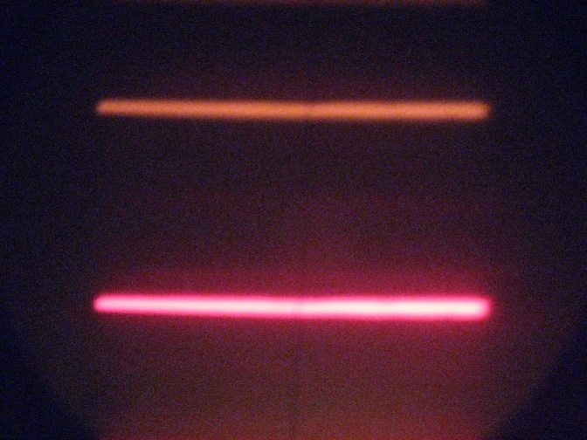

Fig 5. Bottom: Graphical Results of the Critical voltage for Hydrogen. Top: Pictures of the He I spectrum

|  |  |  |  |  |
| --- | --- | --- | --- | --- |
| Table of He Data | | | | |
| Upper Curve | | | | |
| n | I (Amps) | Accelerating Voltage (eV) | | Difference (eV) |
| 1 | 6.757 | 18.04 | +/- .02 | --- |
| 2 | 6.204 | 18.78 | +/- .02 | 0.74 |
| 3 | 6.03 | 20.9 | +/- .02 | 2.86 |
| 4 | 5.554 | 21.78 | +/- .02 | 3.74 |
| Lower Curve | | | | |
| n | I (Amps) | Accelerating Voltage (eV) | | Difference (eV) |
| 1 |  | 18.06 | +/- .02 | --- |
| 2 | 5.453 | 18.72 | +/- .02 | 0.66 |
| 3 | 4.062 | 20.88 | +/- .02 | 2.82 |
| 4 | 5.225 | 21.56 | +/- .02 | 3.5 |

phi L phi R theta L theta R deviation Delta theta Correction

Deg Minutes Deg Minutes Deg Deg Deg Deg Deg

255 213.5 0 20.76666667 20.73333333 0.023570226 20.75 254.75

250 213 0 15.76666667 21.23333333 3.86551707 18.5 252.5

255.5 214 0 21.26666667 20.23333333 0.730677007 20.75 254.75

255 213.5 0 20.76666667 20.73333333 0.023570226 20.75 254.75

255 4 213 20 20.83333333 20.9 0.047140452

1.65443E-06

Table 1. Table for the data values in the graph in Fig. 4

|  |  |  |  |  |
| --- | --- | --- | --- | --- |
| Observations | | | |  |
| Color | Theta L | Theta R | Lambda | n |
| Violet | 15.6 | 15.8 | 4.5E-07 | 1 |
| Blue | 16.4 | 16.3 | 4.7E-07 | 2 |
| Green 1 | 17.2 | 17.5 | 4.9E-07 | 3 |
| Green 2 | 17.5 | 17.7 | 5.0E-07 | 4 |
| Yellow | 21.1 | 21.1 | 6.0E-07 | 5 |
| Red | 24.2 | 24.0 | 6.7E-07 | 6 |

Table 2. table for the Data values of the picture in Fig. 4  
Overall I got very good result for Helium. The following table summarizes Them. I found that by taking the difference in the states in He and comparing them to the differences in the energy levels of He that each of the peak corresponded to a different P – S3 transition for the He I. Using the data values I got an average Plank’s constant of roughly 6.19 E -34 Js which while not as good as I hoped was pretty close. I am not sure where the data came from so I am not sure of the error. When I looked that -values for He I, I found that they instead corresponded to the Balmier series transitions to the P-shell orbital’s but not the same transitions as for the graphical data. To calibrate the He I spectrum I had to use Sodium Lamp. The Sodium had the interesting property that the I observed a double lines. (Unfortunately I could not recover the picture.) These double lines are caused by coupling of the orbital momentum and spin of the atoms. orbital angular moment of the outermost electron. This electron experiences an electric field

1. Not all the wavelength’s from part 3 correspond to ones in part 4. In fact many of the wavelengths the diffraction grating detected were S to P and **P to D** orbital transitions.
   1. Part of the reason for this is the fact that some of the Helium wavelengths lines are attenuated by the atmosphere.